CWB Small Biz Sprint Clean Up Release Notes: Build 1.5.13.
Dec 13, 2021 v1

Table of Contents
2 Links to Forms, Workspace, TM and Jira UAT boards 3
3 Prepared for this Release 4
3.1 Issues that Have Been Closed – N/A 4
3.2 Environment Issues 4
3.3 Known Issue 4
3.4 Additional Information 5
3.5 Included Testable Stories: Total – N/A 7
3.6 Included Testable Changes: Total – 1 7
3.7 Included Un-Testable Stories/Bugs/Change– N/A 7
4 Temenos Dev/QA Defects Fixed within this Build – Total – N/A 7
5 CWB QA Defects Fixed with this Build – Total – 2 8
6 Accessibility Items 8
7 Reporting Defects 8
8 Defect Severity Levels 8

2 Links to Forms, Workspace, TM and Jira UAT boards

Here are the links for UAT Workspace, Journey Manager and Temenos Jira boards, please note that CWB team will not have access to the JM environment:
Dev
- Dev JM - https://dev.cwb.avoka-transact.com/manager/login.htm
- Dev Form - https://dev.cwb.avoka-transact.com/cwbank/servlet/SmartForm.html?formCode=cwb-business-init
- Dev Workspace - https://dev.cwb.avoka-transact.com/workspaces-cwb/secure/app/workspaces/20.05/#/
- Dev Analytics - https://dev.cwb.avoka-transact.com/insights/login.htm

SIT
- SIT JM - https://test.cwb.avoka-transact.com/manager/login.htm
- SIT form - https://test.cwb.avoka-transact.com/cwbank/servlet/SmartForm.html?formCode=cwb-business-init
- SIT Workspace - https://test.cwb.avoka-transact.com/workspaces-cwb/secure/app/workspaces/20.05/#/
- SIT Analytics - https://test.cwb.avoka-transact.com/insights/login.htm
- Launch Form - https://test.cwb.avoka-transact.com/cwbank/servlet/SmartForm.html?formCode=launchform-cwb

CWB-SIT
- CWB-SIT JM - https://admin.staging.cwb.avoka-transact.com/manager/login.htm
- CWB-SIT Form - https://staging.cwb.avoka-transact.com/cwbank/servlet/SmartForm.html?formCode=cwb-business-init
- CWB-SIT Workspace 20.05 - https://staging.cwb.avoka-transact.com/workspaces-cwb/app/workspaces/20.05/#/
- CWB-SIT Analytics - https://staging.cwb.avoka-transact.com/insights/login.htm
- CWB SIT Launch Form: https://staging.cwb.avoka-transact.com/cwbank/servlet/SmartForm.html?formCode=launchform-cwb
- COVR Match Mock URL: https://staging.cwb.avoka-transact.com/cwbank/servlet/SmartForm.html?formCode=cwb-business-init&testConfigProfile=skipPINBizValidation

CWB-UAT
- CWB-UAT JM - https://admin.preprod.cwb.avoka-transact.com/manager/login.htm
- CWB-UAT Form - https://preprod.cwb.avoka-transact.com/cwbank/servlet/SmartForm.html?formCode=cwb-business-init
- CWB-UAT Workspace - https://preprod.cwb.avoka-transact.com/workspaces-cwb/login.htm
  - 20.5 version
- CWB-UAT Analytics - https://admin.preprod.cwb.avoka-transact.com/insights/login.htm
- CWB UAT Launch Form: https://preprod.cwb.avoka-transact.com/cwbank/servlet/SmartForm.html?formCode=launchform-cwb

Motive Workspace 20.05
- Motive-SIT Workspace https://staging.cwb.avoka-transact.com/workspaces-motive/app/motive-workspaces/20.05/#/

JIRA
- Temenos Jira board CWB Small Biz DCO:
https://servicedesk.temenos.com/tickets/secure/RapidBoard.jspa?rapidView=630&projectKey=CWBSB

3 Prepared for this Release

The following stories were tested on the below devices using a combination of physical devices and virtual devices using the tool Browserstack.
- Desktop
  - Apple Safari - current version – virtual device
  - Google Chrome - current version – physical device
  - Microsoft Edge - current version – physical device
  - Microsoft Internet Explorer - 11.0 – physical device
  - Mozilla Firefox - curent version – physical device
- Mobile
  - Apple Safari on Apple iOS 7 or later devices – virtual device
  - Google Chrome on Android version 4 or later devices – virtual device

Issues that Have Been Closed – N/A

Environment Issues
N/A

Known Issue
In the Business Disclosure Page for Sole Proprietor the is typo with the word resident
- CWBSB-1744- This known issue will be fixed in Build for Dec 14, 2021.
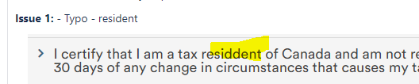

Additional Information
  - Change in flow as to how application routed to Onboarding Queue will work per CWBSB-1369: Modify handling of T24 provisioning error
    - if any of T24 Provisioning error out (Create CIF, Create BIZ CIF, Create Products, Create Contact Log or Create PAN)
    - Route to Onboarding Queue (Claim and select Complete or Declined in Review form - staff will manually provision in T24)
    - Applicant receives Approved Email
    - No Deposit form will be generated
Note:
- Review Complete email is generated when Approved via Manual Review Queue AND all T24 provisioning calls are successful (otherwise route to Onboarding Queue)
- Deposit forms are generated when- Auto-approved or approved via the Manual Review Queue AND all T24 provisioning calls are successful (otherwise route to Onboarding Queue)
- Application Complete email are generated after Deposit form has been completed

- Configure Nurture Email
  - In JM - Go to Systems/Scheduled Job/CWB Small Biz Nurture Emails Scheduled Job/Edit/Parameters - see timing are configurable and per requirements for 45 days and max Reminder of 3
  - Note: For testing purpose - configure the reminderFrequency to 15m and authSignerExpiryTime to 1h – so that we do not have what 5 days for Nurture email and 45 days Auth Signer to expired.
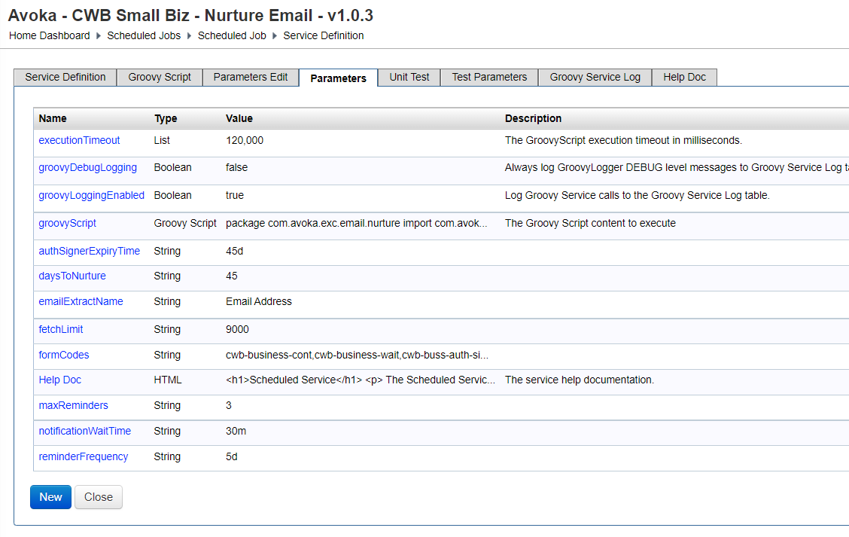
- Okta Prefill Service
  - Please only have 1 incognito window open only (The application that you want to sign login to Okta should be the only one in incognito mode)
  - Been Implemented for CWB (Not Motive)
  - If you select Yes to existing customer ad login to Okta create issues in Review form See (CWBSB-1442)

- Business Retries to Retrieve COVR Report
  - The duration of retries is set up under Scheduled Jobs: Systems/Scheduled Jobs

Click on the Initial Business Search Polling or Extend Business Search Polling to configure the duration.

    - During Polling retries process, when Business search, if the Order Report is at a Requested state and the Business Search Retries never get a Completed Status, then user will see the “We are reviewing your application page”. The application will not be routed to Workspace until polling reach maximum time and no report is retrieved – this is decision per details from abandoned stories (CWBSB-1025 and CWBSB-1179)

- Concurrent Check (Turn On & Off)
  - To turn On/Off Concurrent Check – In JM go to Forms/Organization/Canadian Western Bank/Properties
ConcurrentCheckSkip is set to true (This will skip this check)


- Commercial Credit Pull and Hard Pull
  - Commercial Credit Pull only executed when Business Type = Corp and application has LOC
- Not Seeing First Thing First Page (Due to Cookie)
  - The First Thing First page was missing and seeing Existing Customer Check page as the 1st page
  - This only happens you create multiple application at the same time one after another on the same computer due to cookie setting in the application – not a real-life scenario.
  - Dev implemented a solution that expired this cookie after 3 minutes, if user start an application and then wait 3 minutes and start another application this will no longer occur
Impact to testing:
    - None

- Browser Specific Issue in IE 11 (Existing Issue found in Motive and Personal DCO)
  - Flinks Page- More Options Menu loads behind the page (Workaround is to resize the browser. Once resized the Option menus pop to the front)
  - Phone number on Desktop is clickable (In other supported Browser Desktop Phone number is Not clickable. Phone Number is clickable on mobile only)
  - Rendering Step Title style of H5 as unbold. (Other bowers render H5 as bold). It is a Browser specific issue that Dev team has no control over. Step title in IE 11 will look different than other browsers.
Impact to testing:
- Testing in IE 11 Browser
- Note: November 30, 2020, the Microsoft Teams web app will no longer support IE 11.
- From August 17, 2021, the remaining Microsoft 365 apps and services will no longer support the browser.

Included Testable Stories: Total – N/A
High level Notes/Comments are documented in this table, however, please see the Jira number Comments for more details.
Jira # | Description | Outstanding/Known Issues, Comments, Notes | Number
 |  | TOTAL

Included Testable Changes: Total – 1
High level Notes/Comments are documented in this table, however, please see the Jira number Comments for more details.
Jira # | Description | Outstanding Issues, Comments, Notes | Number
CWBSB-1715 | Form updates - tax residency (regulatory) | Tested by Temenos QA  Known Issue: Typo with the word resident – this known issue will be fixed in Build for Dec 14, 2021. | 1
 |  | TOTAL | 1

Included Un-Testable Stories/Bugs/Change– N/A
High level Notes/Comments are documented in this table, however, please see the Jira number Comments for more details.
These include Non-Functional Requirements and other items that can be validated via other testing such as email generation testing, end -to-end testing, etc.

4 Temenos Dev/QA Defects Fixed within this Build – Total – N/A
The following defects have been included in this release as reported by Temenos Dev/QA, please see the Jira number Comments for more details.

5 CWB QA Defects Fixed with this Build – Total – 2
The following defects have been included in this release as reported by CWB QA during UAT and all assigned back to CWB, please see the Jira number Comments for more details.
Bug # | Description | Priority | Outstanding Issues, Comments, Notes | Number
CWBSB-1675 | INFINITY: 7905 Username in Digital Banking Site is NOT Showing the Last 8 Digits of PAN when created via Small Biz DCO application  PLEASE READ: Please use customer where their email Information will not be scrubbed in T24 to person@example.com, as Infinity Activation email can only be sent to cwbank.com email address in testing environment. | Critical | Tested by Temenos QA
CWBSB-1733 | SBDCO Incorrect count of days left to complete the application on 'Your associates will join us soon' page - TFS # 194733 | High | Tested by Temenos QA
 |  |  | TOTAL | 2

6 Accessibility Items
- No Accessibility items included with this release.

7 Reporting Defects
When reporting Defects in UAT, please follow instructions below:
- Select Issue Type: UAT Issue
- Summary: Prefix with page issue is on and include short description
- Description: Include steps to reproduce, Actual and Expected results
- Priority: (see our guidance on selecting a priority in section 7 below)
- Environment: Device/Browser/OS information (and if it is across all, provide list)
- Linked Issue: Select story issue is linked.

8 Defect Severity Levels
Level | Description
Severity 1 or Critical | Critical/Showstopper/Blocker: This affects, or materially fails to comply with the acceptance criteria for, critical functionality or critical data. This does not have a workaround.
Severity 2 or High | High: The defect affects, or materially fails to comply with the acceptance criteria for, major functionality or major data. It has a workaround but is not obvious and is difficult.
Severity 3 or Medium | Medium: The defect affects minor functionality or non-critical data. It has an easy workaround.
Severity 4 or Low | Low: The defect does not affect functionality or data. It does not need a workaround; no impacts to productivity.

